Welcome To
Trinity Lutheran Church
Lutheran Church—Missouri Synod
A Stephen Ministry Congregation

1354 South Otsego Avenue
Gaylord, Michigan 49735
Church Phone: (989) 732-4816

Church Email: secretary@trinitygaylord.com
www.trinitygaylord.com

Office Hours: Monday through Friday 9am – 1pm

OUR PURPOSE
…is to LOVE GOD, LOVE OTHERS, AND SERVE THE WORLD by worshiping the Lord Jesus, bringing our members into Christ-like maturity, and equipping them through Word and Sacrament for their mission and ministry. We go heart to heart into the world with Jesus, sharing His love, caring for one another, praying, and bringing the lost into a relationship with Christ, by the working of the Holy Spirit.

June 26, 2022
Third Sunday after Pentecost
Preacher: Rev. Ken Bernthal

ABOUT OUR WORSHIP
We welcome all who gather here today! We are blessed to celebrate together the mercy, grace, and love we have from God through the death and resurrection of our Lord Jesus Christ.

Children: Families with children are very welcome here. Having children in church is important so they can begin to learn about their faith in Jesus, and it’s good for the whole congregation to see. Please feel comfortable keeping “squirmy” kids in the service. This is where they belong, too!

Pew Cards: Guests and Members, please fill out the Guest/Member card located on the back of the pew in front of you and pass it to the end of the aisle. If you forget you can put it in the offering plate on your way out.

If standing is difficult: Please feel free to remain seated during any portion of the service. Please let an Elder or Usher know if you need communion in your pew seat.

About our celebration of Holy Communion: We celebrate the Lord’s Supper in the confession and glad confidence that, as he says, our Lord gives into our mouths not only bread and wine but his very body and blood to eat and to drink for the forgiveness of sins and to strengthen our union with him and with one another. Our Lord invites to his table those who trust his words, repent of all sin, and set aside any refusal to forgive and love as he forgives and loves us, that they may show forth his death until he comes.

Because those who eat and drink our Lord’s body and blood contrary to that which is stated above do so to their great harm, and also because Holy Communion is a confession of the faith which is confessed at this altar. Anyone who is not yet instructed, in doubt, or who hold a confession differing from that of the Lutheran Church—Missouri Synod, and yet desire to receive the sacrament, are asked first to speak with Pastor. Those not communing are still invited to come forward for a blessing from Pastor, and you may indicate this by crossing your arms over your chest.
TTTTTT
GREETING

P Peace be with you.
C And also with you.
P Let us Pray
T ORDER OF SERVICE T
(The liturgy is from Divine Service Setting four LSB pg. 203ff)

OPENING HYMN
Alleluia! Sing to Jesus LSB 821 sts. 1–4
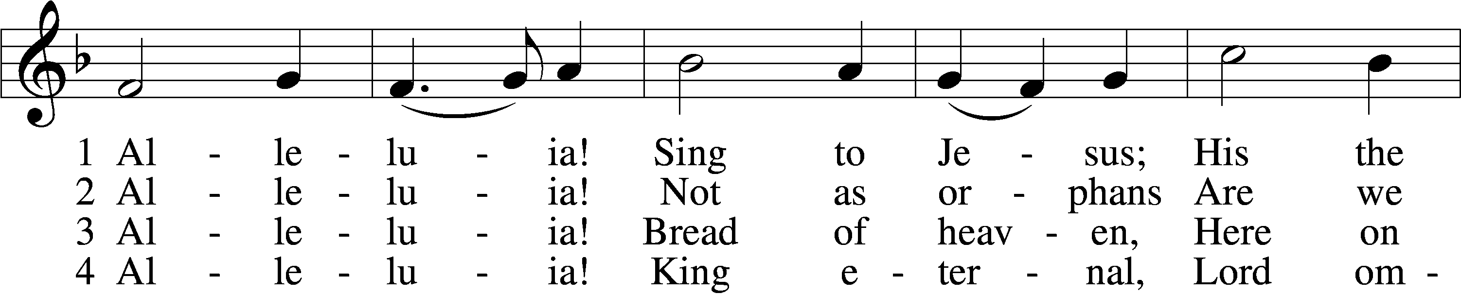
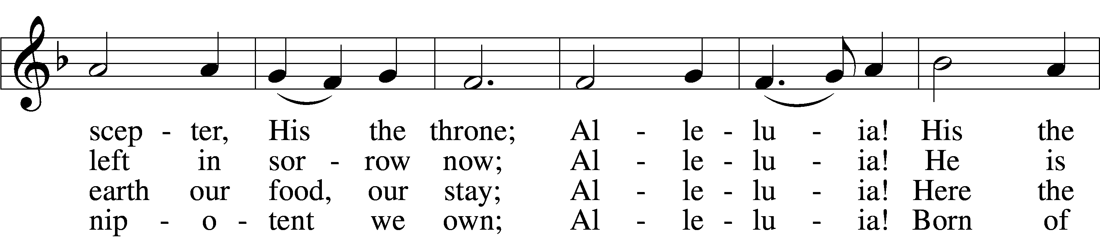
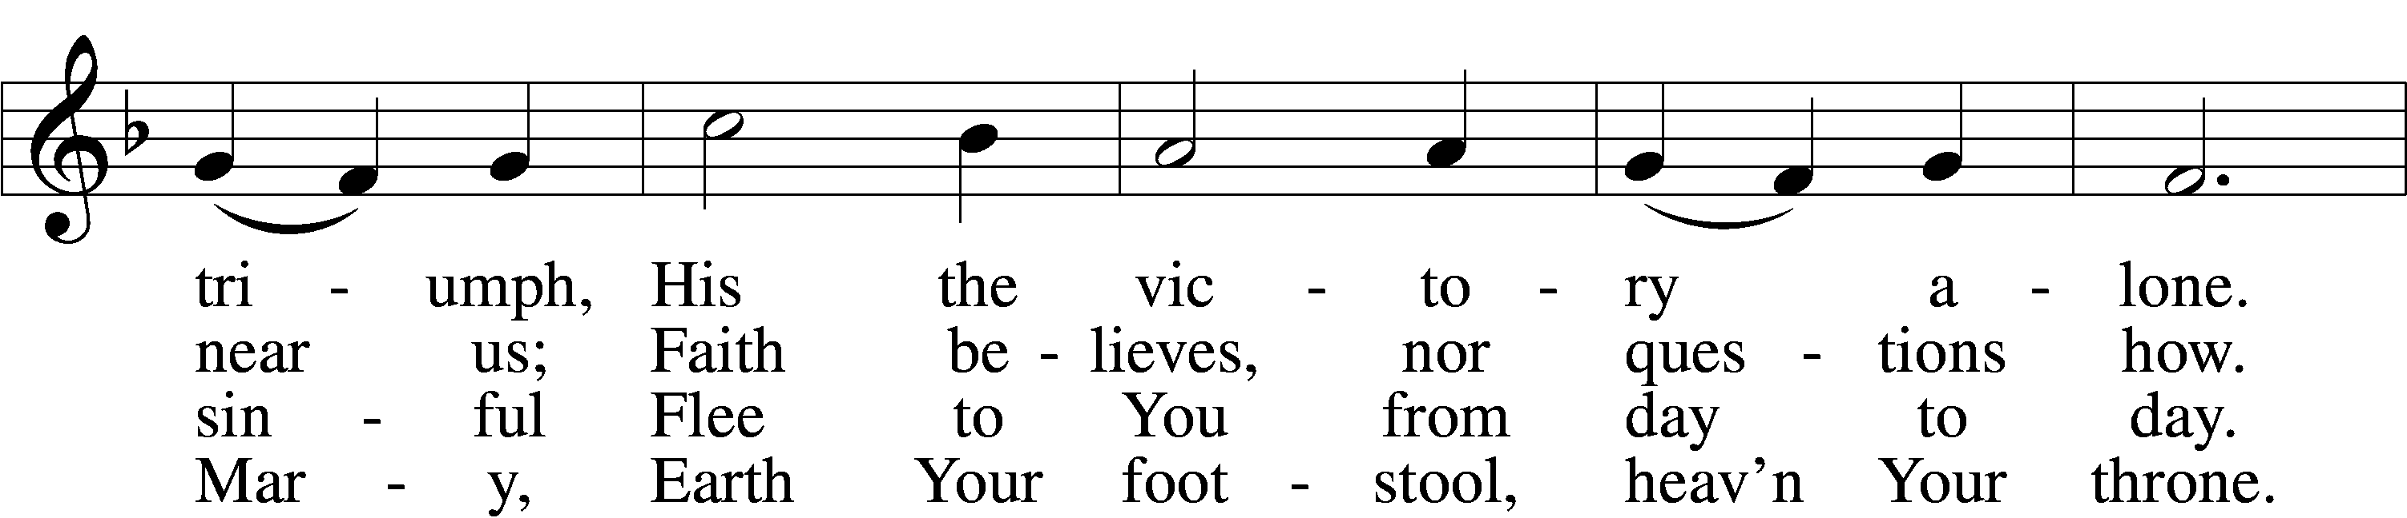
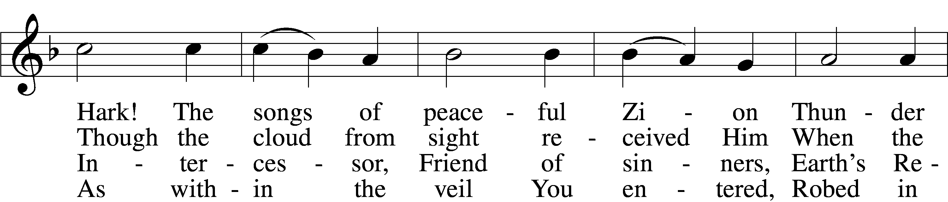
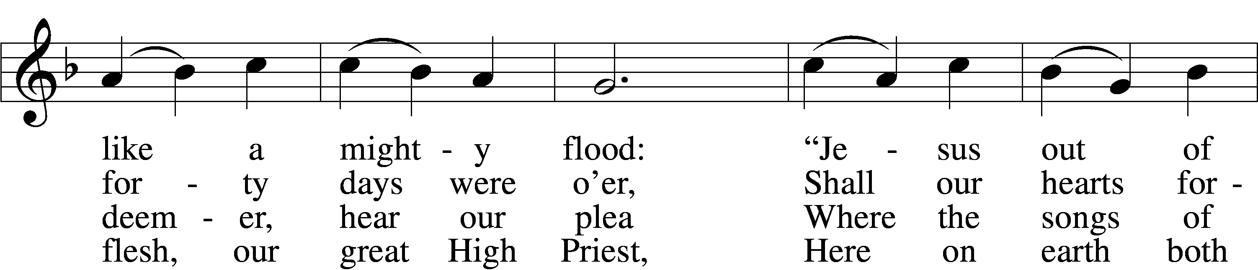
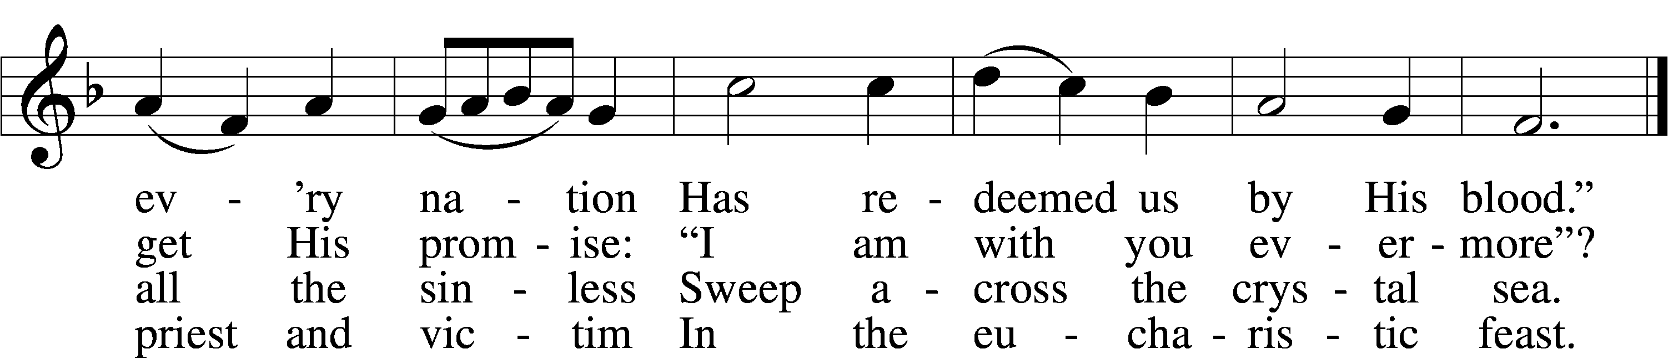
Text: William C. Dix, 1837–98, alt.
Tune: Rowland H. Prichard, 1811–87
Text and tune: Public domai

Please stand as able
CONFESSION and ABSOLUTION
The sign of the cross may be made by all in remembrance of their Baptism.

P In the name of the Father and of the T Son and of the Holy Spirit.
C Amen.
P Our help is in the name of the Lord,
C who made heaven and earth.
P If You, O Lord, kept a record of sins, O Lord, who could stand?
C But with You there is forgiveness; therefore, You are feared.
P Since we are gathered to hear God’s Word, call upon Him in prayer and praise, and receive the body and blood of our Lord Jesus Christ in the fellowship of this altar, let us first consider our unworthiness and confess before God and one another that we have sinned in thought, word, and deed, and that we cannot free ourselves from our sinful condition. Together as His people let us take refuge in the infinite mercy of God, our heavenly Father, seeking His grace for the sake of Christ, and saying: God, be merciful to me, a sinner.
C Almighty God, have mercy upon us, forgive us our sins, and lead us to everlasting life. Amen.
P Almighty God in His mercy has given His Son to die for you and for His sake forgives you all your sins. As a called and ordained servant of Christ, and by His authority, I therefore forgive you all your sins in the name of the Father and of the T Son and of the Holy Spirit.
C Amen.

SERVICE OF THE WORD
INTROIT Psalm 85:8–10, 13; antiphon: v. 7
P Show us your steadfast love, O Lord,
and grant us your salvation.
C Let me hear what God the Lord will speak,
for he will speak peace to his people, to his saints; but let them not turn back
to folly.
P Surely his salvation is near to those who fear him,
that glory may dwell in our land.
C Steadfast love and faithfulness meet;
righteousness and peace kiss each other.
P Righteousness will go before him
and make his footsteps a way
ALL Glory be to the Father and to the Son
and to the Holy Spirit;
as it was in the beginning,
is now, and will be forever. Amen.
P Show us your steadfast love, O Lord,
and grant us your salvation.

SERVICE OF THE WORD
KYRIE LSB 204
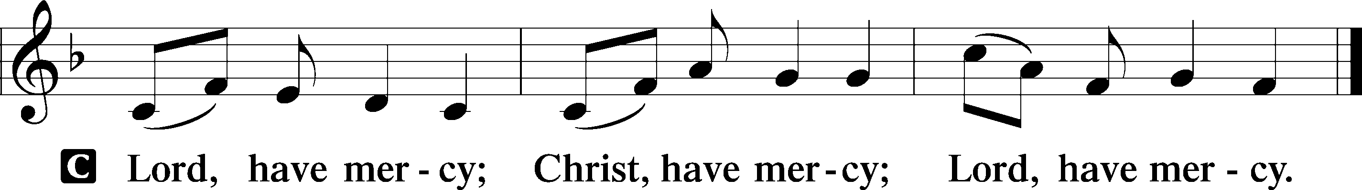

HYMN OF PRAISE
GLORIA IN EXCELSIS LSB 204
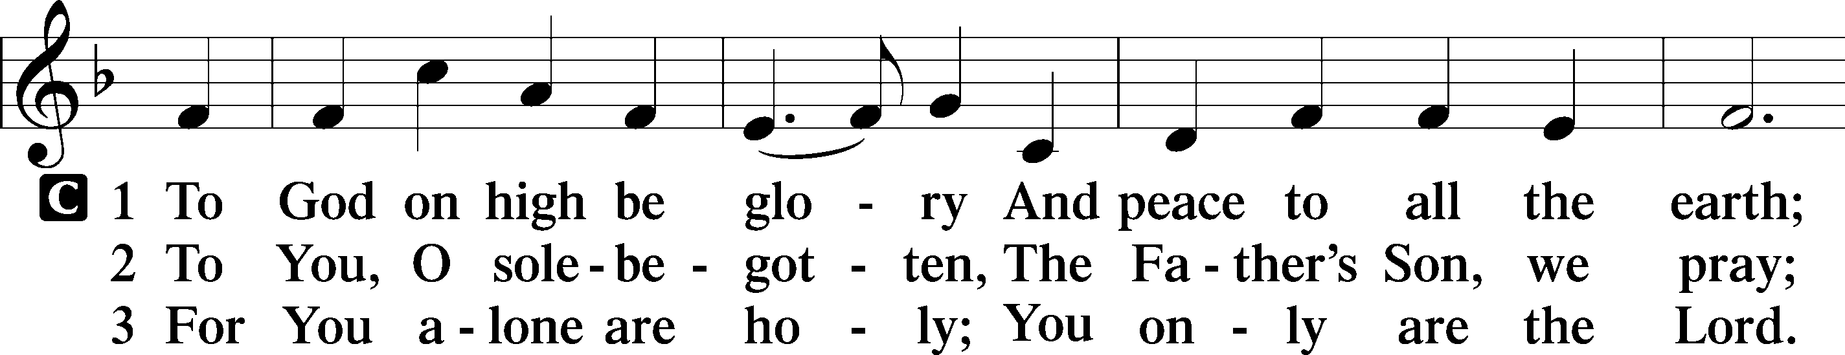
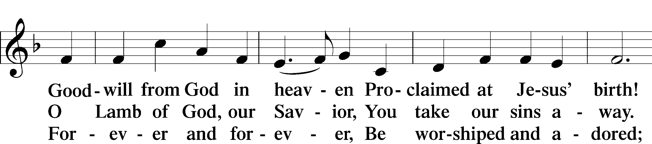
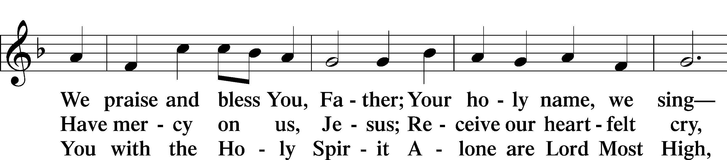
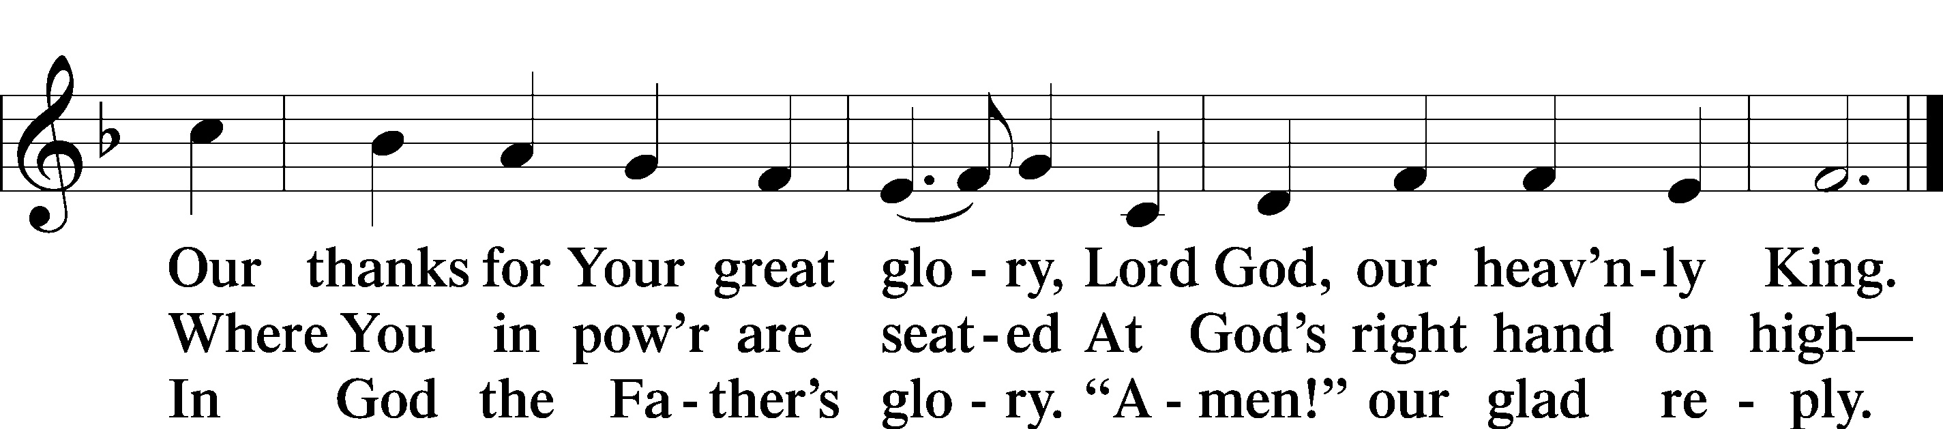

Text: Stephen P. Starke

SALUTATION AND COLLECT OF THE DAY
P The Lord be with you.
C And also with you.

P Let us pray.
Lord of all power and might, author and giver of all good things, graft into our hearts the love of Your name and nourish us with all goodness that we may love and serve our neighbor; through Jesus Christ, Your Son, our Lord, who lives and reigns with You and the Holy Spirit, one God, now and forever.
C Amen.
Please be seated
OLD TESTAMENT READING 1 Kings 19:9b–21
Behold, the word of the Lord came to [Elijah], and he said to him, “What are you doing here, Elijah?” ¹⁰He said, “I have been very jealous for the Lord, the God of hosts. For the people of Israel have forsaken your covenant, thrown down your altars, and killed your prophets with the sword, and I, even I only, am left, and they seek my life, to take it away.” ¹¹And he said, “Go out and stand on the mount before the Lord.” And behold, the Lord passed by, and a great and strong wind tore the mountains and broke in pieces the rocks before the Lord, but the Lord was not in the wind. And after the wind an earthquake, but the Lord was not in the earthquake. ¹²And after the earthquake a fire, but the Lord was not in the fire. And after the fire the sound of a low whisper. ¹³And when Elijah heard it, he wrapped his face in his cloak and went out and stood at the entrance of the cave. And behold, there came a voice to him and said, “What are you doing here, Elijah?” ¹⁴He said, “I have been very jealous for the Lord, the God of hosts. For the people of Israel have forsaken your covenant, thrown down your altars, and killed your prophets with the sword, and I, even I only, am left, and they seek my life, to take it away.” ¹⁵And the Lord said to him, “Go, return on your way to the wilderness of Damascus. And when you arrive, you shall anoint Hazael to be king over Syria. ¹⁶And Jehu the son of Nimshi you shall anoint to be king over Israel, and Elisha the son of Shaphat of Abel-meholah you shall anoint to be prophet in your place. ¹⁷And the one who escapes from the sword of Hazael shall Jehu put to death, and the one who escapes from the sword of Jehu shall Elisha put to death. ¹⁸Yet I will leave seven thousand in Israel, all the knees that have not bowed to Baal, and every mouth that has not kissed him.”
¹⁹So he departed from there and found Elisha the son of Shaphat, who was plowing with twelve yoke of oxen in front of him, and he was with the twelfth. Elijah passed by him and cast his cloak upon him. ²⁰And he left the oxen and ran after Elijah and said, “Let me kiss my father and my mother, and then I will follow you.” And he said to him, “Go back again, for what have I done to you?” ²¹And he returned from following him and took the yoke of oxen and sacrificed them and boiled their flesh with the yokes of the oxen and gave it to the people, and they ate. Then he arose and went after Elijah and assisted him.

P This is the Word of the Lord.
C Thanks be to God.

EPISTLE Galatians 5:1, 13–25
¹For freedom Christ has set us free; stand firm therefore, and do not submit again to a yoke of slavery. . . .
¹³For you were called to freedom, brothers. Only do not use your freedom as an opportunity for the flesh, but through love serve one another. ¹⁴For the whole law is fulfilled in one word: “You shall love your neighbor as yourself.” ¹⁵But if you bite and devour one another, watch out that you are not consumed by one another.
¹⁶But I say, walk by the Spirit, and you will not gratify the desires of the flesh. ¹⁷For the desires of the flesh are against the Spirit, and the desires of the Spirit are against the flesh, for these are opposed to each other, to keep you from doing the things you want to do. ¹⁸But if you are led by the Spirit, you are not under the law. ¹⁹Now the works of the flesh are evident: sexual immorality, impurity, sensuality, ²⁰idolatry, sorcery, enmity, strife, jealousy, fits of anger, rivalries, dissensions, divisions, ²¹envy, drunkenness, orgies, and things like these. I warn you, as I warned you before, that those who do such things will not inherit the kingdom of God. ²²But the fruit of the Spirit is love, joy, peace, patience, kindness, goodness, faithfulness, ²³gentleness, self-control; against such things there is no law. ²⁴And those who belong to Christ Jesus have crucified the flesh with its passions and desires.
²⁵If we live by the Spirit, let us also walk by the Spirit.

P This is the Word of the Lord.
C Thanks be to God.

Please stand as able

ALLELUIA AND VERSE
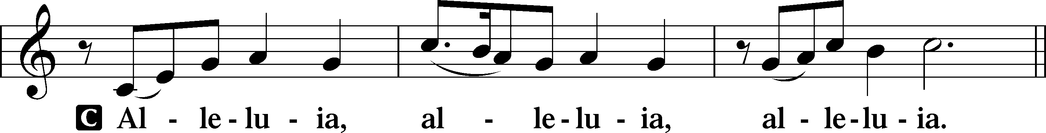
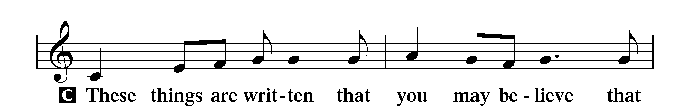

Continued on next page
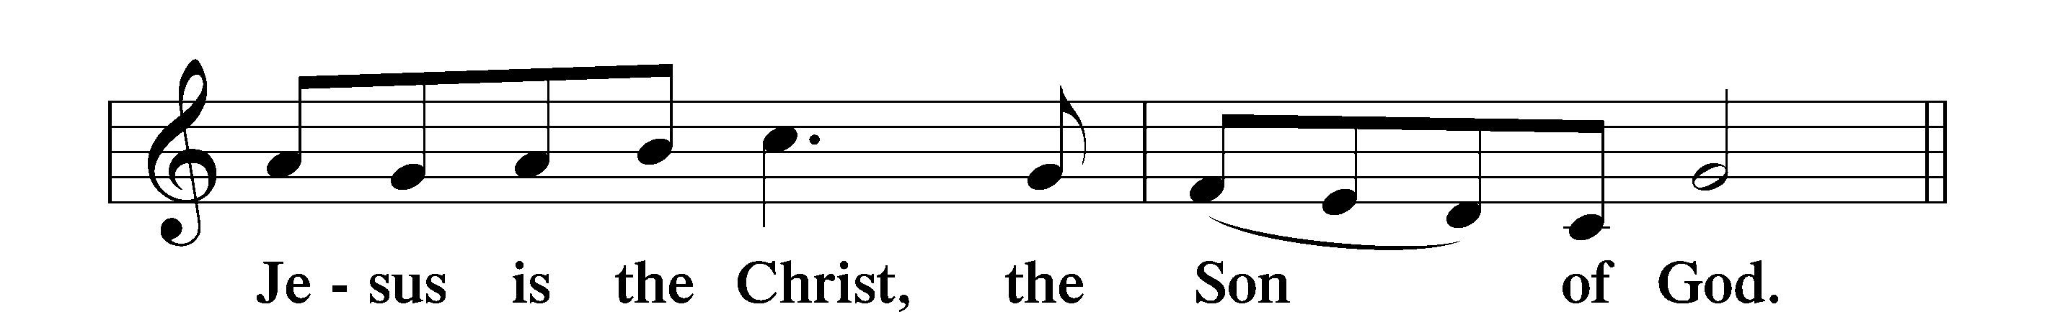
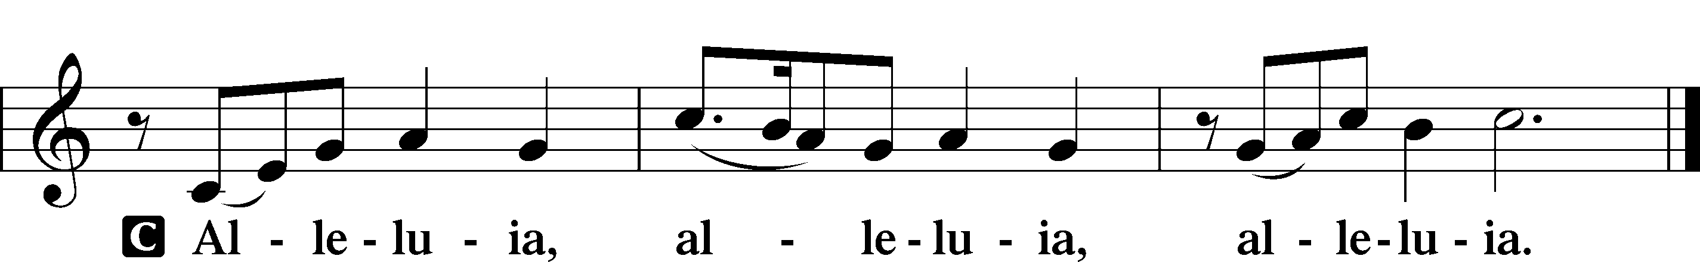

HOLY GOSPEL Luke 9:51-62
P The Holy Gospel according to St. Luke, the ninth chapter.
C Glory to You, O Lord.

⁵¹When the days drew near for [Jesus] to be taken up, he set his face to go to Jerusalem. ⁵²And he sent messengers ahead of him, who went and entered a village of the Samaritans, to make preparations for him. ⁵³But the people did not receive him, because his face was set toward Jerusalem. ⁵⁴And when his disciples James and John saw it, they said, “Lord, do you want us to tell fire to come down from heaven and consume them?” ⁵⁵But he turned and rebuked them. ⁵⁶And they went on to another village.
⁵⁷As they were going along the road, someone said to him, “I will follow you wherever you go.” ⁵⁸And Jesus said to him, “Foxes have holes, and birds of the air have nests, but the Son of Man has nowhere to lay his head.” ⁵⁹To another he said, “Follow me.” But he said, “Lord, let me first go and bury my father.” ⁶⁰And Jesus said to him, “Leave the dead to bury their own dead. But as for you, go and proclaim the kingdom of God.” ⁶¹Yet another said, “I will follow you, Lord, but let me first say farewell to those at my home.” ⁶²Jesus said to him, “No one who puts his hand to the plow and looks back is fit for the kingdom of God.”

P This is the Gospel of the Lord.
C Praise to You, O Christ.

NICENE CREED
C I believe in one God,
the Father Almighty,
maker of heaven and earth
and of all things visible and invisible.
And in one Lord Jesus Christ,
the only-begotten Son of God,
begotten of His Father before all worlds,
God of God, Light of Light,
very God of very God,
begotten, not made,
being of one substance with the Father,
by whom all things were made;
who for us men and for our salvation came down from heaven
and was incarnate by the Holy Spirit of the virgin Mary
and was made man;
and was crucified also for us under Pontius Pilate.
He suffered and was buried.
And the third day He rose again according to the Scriptures
and ascended into heaven
and sits at the right hand of the Father.
And He will come again with glory to judge both the living and the dead,
whose kingdom will have no end.
And I believe in the Holy Spirit,
the Lord and giver of life,
who proceeds from the Father and the Son,
who with the Father and the Son together is worshiped and glorified,
who spoke by the prophets.
And I believe in one holy Christian and apostolic Church,
I acknowledge one Baptism for the remission of sins,
and I look for the resurrection of the dead
and the life T of the world to come. Amen.

Please be seated

ALL GOD’S CHILDREN – TALK

SERMON HYMN
Today Your Mercy Calls Us LSB 915
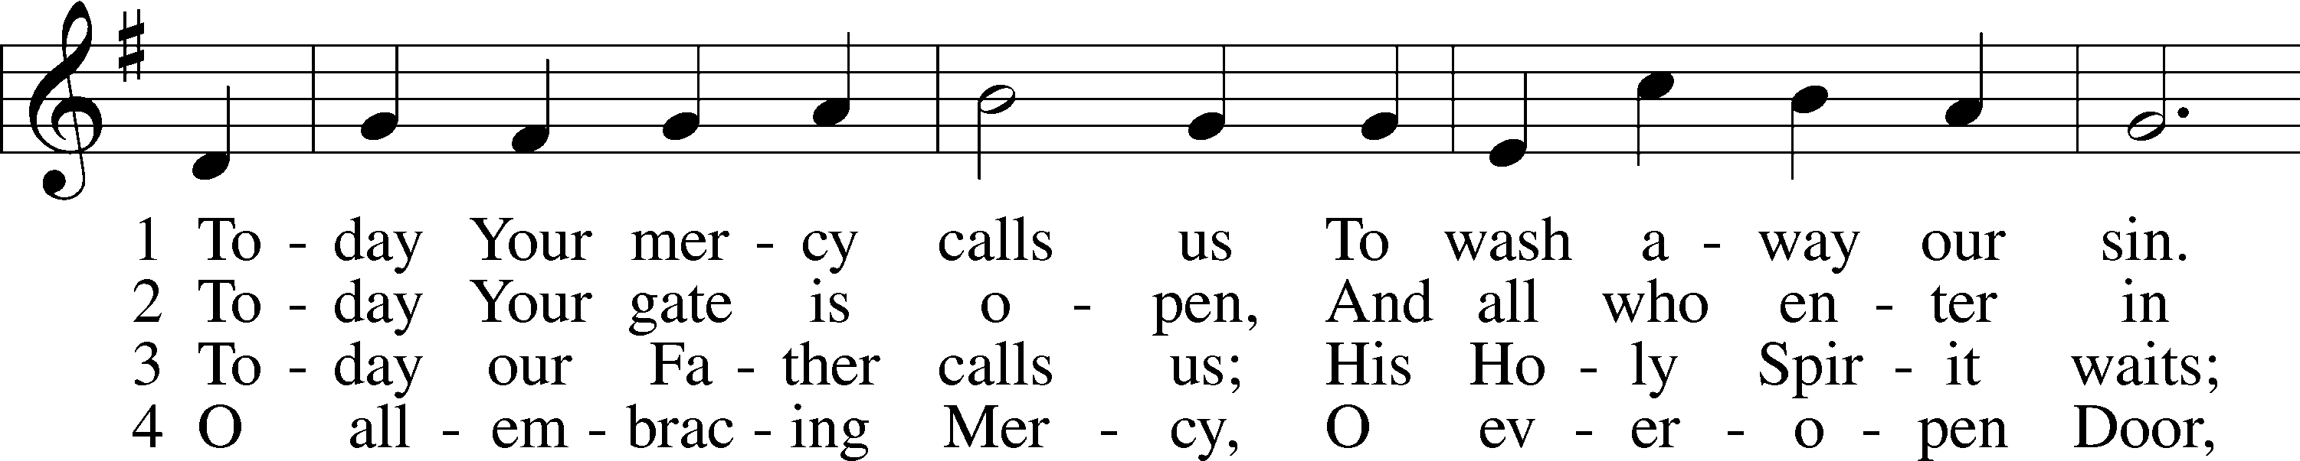
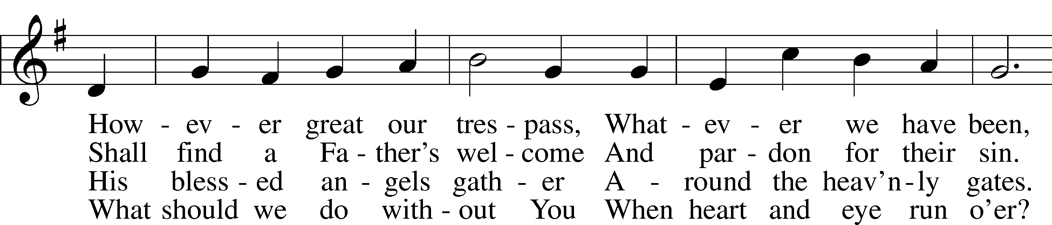
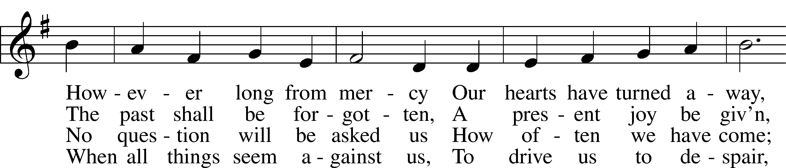
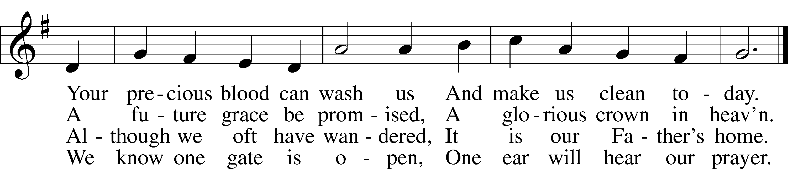

Text: Oswald Allen, 1816–78, alt.
Tune: Friedrich K. Anthes, 1812–after 1857
Text and tune: Public domain

SERMON

Please stand as able

PRAYER of the CHURCH
After each Segment:
P Lord, in Your Mercy,
C Hear our Prayer.
After Final Segment:
P Hear us as we pray in His name and as He has taught us:
LORD’S PRAYER
C Our Father who art in heaven,
hallowed be Thy name,
Thy kingdom come,
Thy will be done on earth
as it is in heaven;
give us this day our daily bread;
and forgive us our trespasses
as we forgive those
who trespass against us;
and lead us not into temptation,
but deliver us from evil.
For Thine is the kingdom
and the power and the glory
forever and ever. Amen.

SERVICE of the SACRAMENT

PREFACE LSB 208
P The Lord be with you.
C And also with you.
P Lift up your hearts.
C We lift them to the Lord.
P Let us give thanks to the Lord our God.
C It is right to give Him thanks and praise.
P It is truly good, right, and salutary that we should at all times and in all places give thanks to You, O Lord, holy Father, almighty and everlasting God, for the countless blessings You so freely bestow on us and all creation. Above all, we give thanks for Your boundless love shown to us when You sent Your only-begotten Son, Jesus Christ, into our flesh and laid on Him our sin, giving Him into death that we might not die eternally. Because He is now risen from the dead and lives and reigns to all eternity, all who believe in Him will overcome sin and death and will rise again to new life. Therefore with angels and archangels and with all the company of heaven we laud and magnify Your glorious name, evermore praising You and singing:

SANCTUS LSB 208
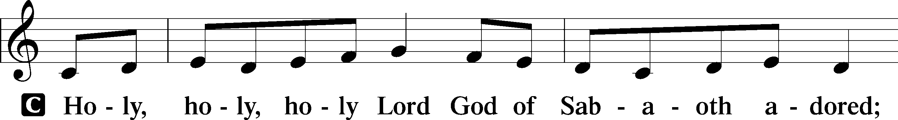
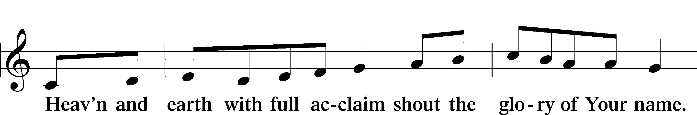
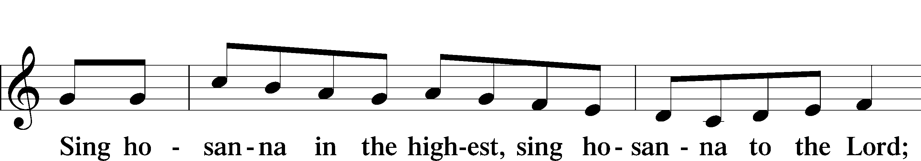

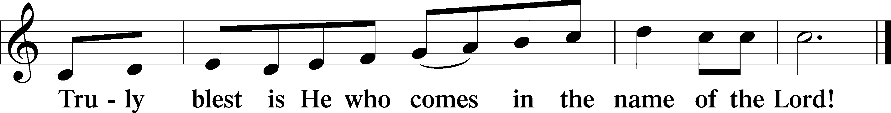

PRAYER OF THANKSGIVING
P Blessed are You, O Lord our God, king of all creation, for You have had mercy on us and given Your only-begotten Son that whoever believes in Him should not perish but have eternal life.
In Your righteous judgment You condemned the sin of Adam and Eve, who ate the forbidden fruit, and You justly barred them and all their children from the tree of life. Yet, in Your great mercy, You promised salvation by a second Adam, Your Son, Jesus Christ, our Lord, and made His cross a life-giving tree for all who trust in Him.

We give You thanks for the redemption You have prepared for us through Jesus Christ. Grant us Your Holy Spirit that we may faithfully eat and drink of the fruits of His cross and receive the blessings of forgiveness, life, and salvation that come to us in His body and blood.

THE WORDS OF OUR LORD
P Our Lord Jesus Christ, on the night when He was betrayed, took bread, and when He had given thanks, He broke it and gave it to the disciples and said: “Take, eat; this is My T body, which is given for you. This do in remembrance of Me.”
In the same way also, He took the cup after supper, and when He had given thanks, He gave it to them, saying: “Drink of it, all of you; this cup is the New Testament in My T blood, which is shed for you for the forgiveness of sins. This do, as often as you drink it, in remembrance of Me.”

PAX DOMINI
P The peace of the Lord be with you always.
C Amen.
AGNUS DEI
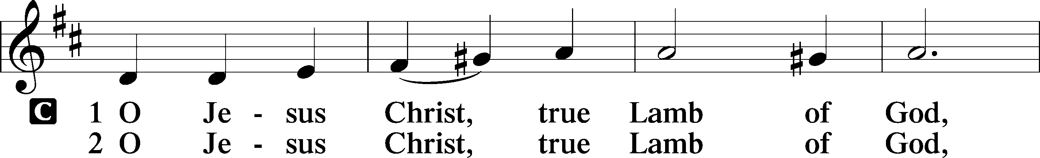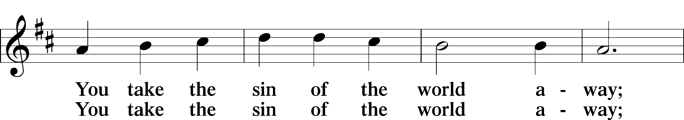
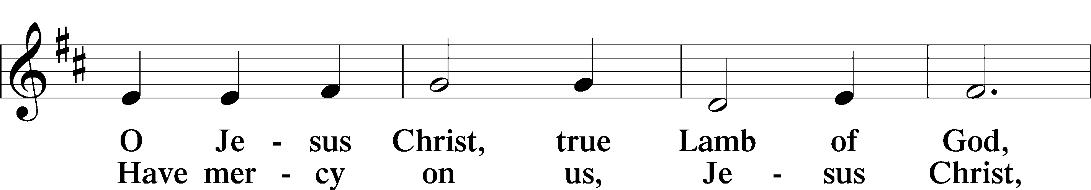
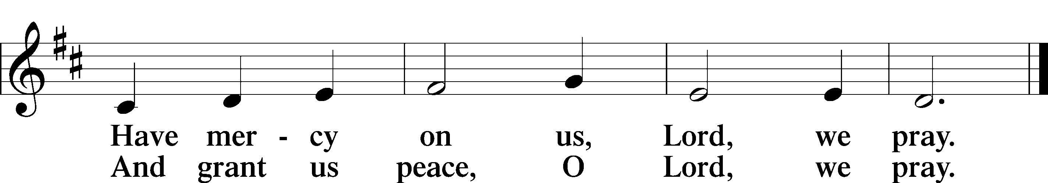
Please be seated

DISTRIBUTION
The pastor and those who assist him receive the body and blood of Christ first, then Communion will be served at the rail. Ushers will help direct you forward via the center aisle; please return to your seats via the side aisles. Gluten-free bread is available for those who need it, as is non-alcoholic grape juice. Simply request either when you come forward to receive Communion.
DISTRIBUTION HYMN
O Savior, Precious Savior LSB 527
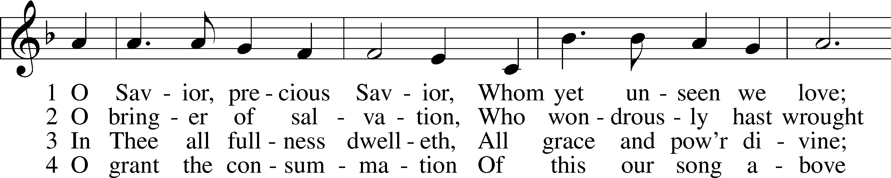
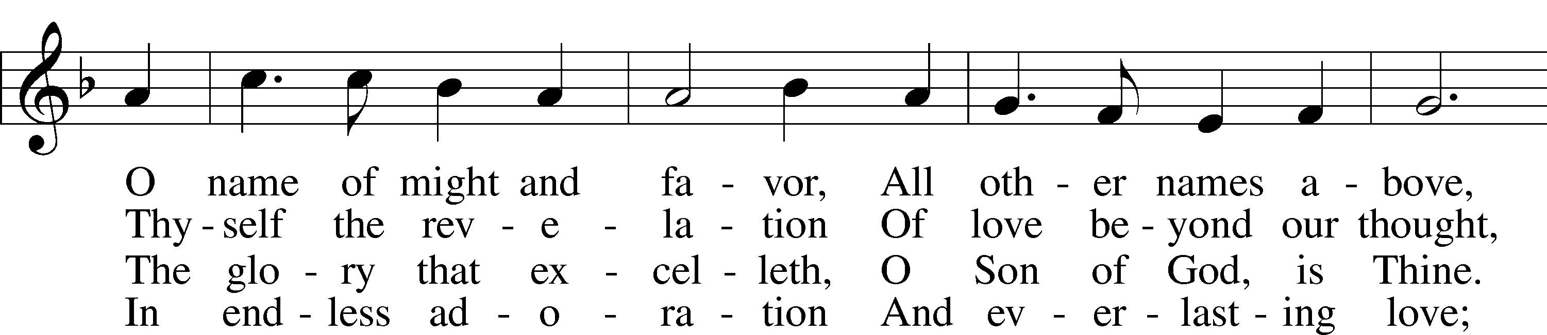
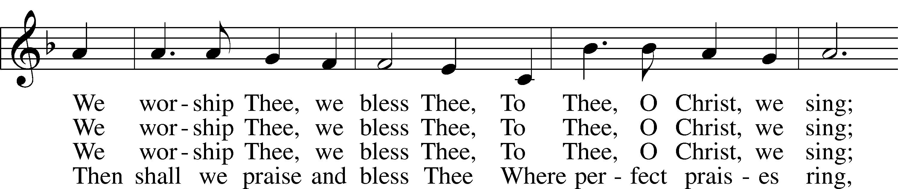
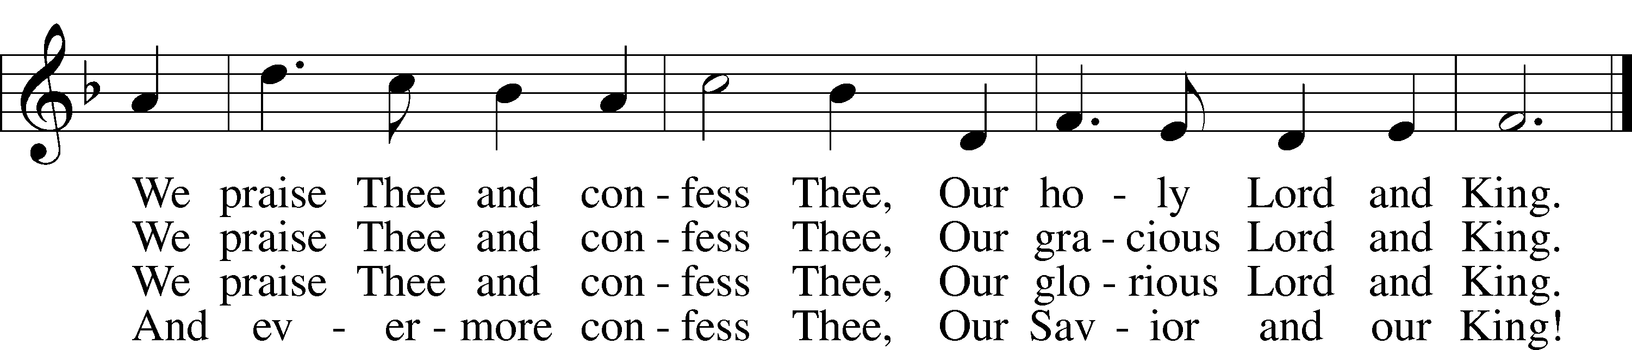

Please stand as able

NUNC DIMITTIS LSB 211
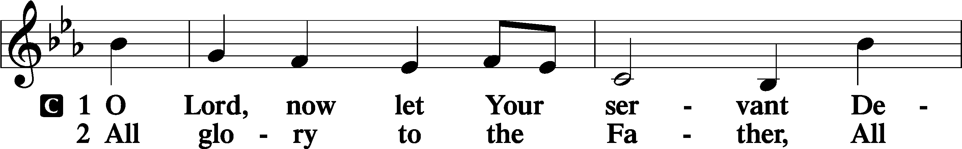
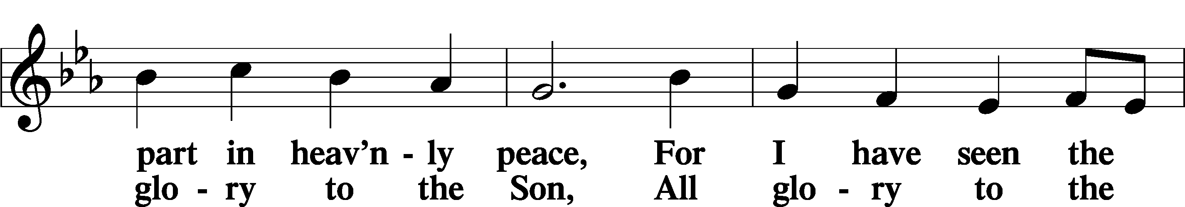
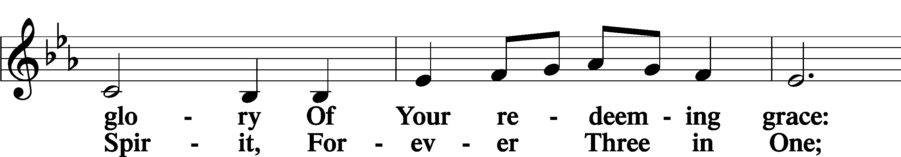
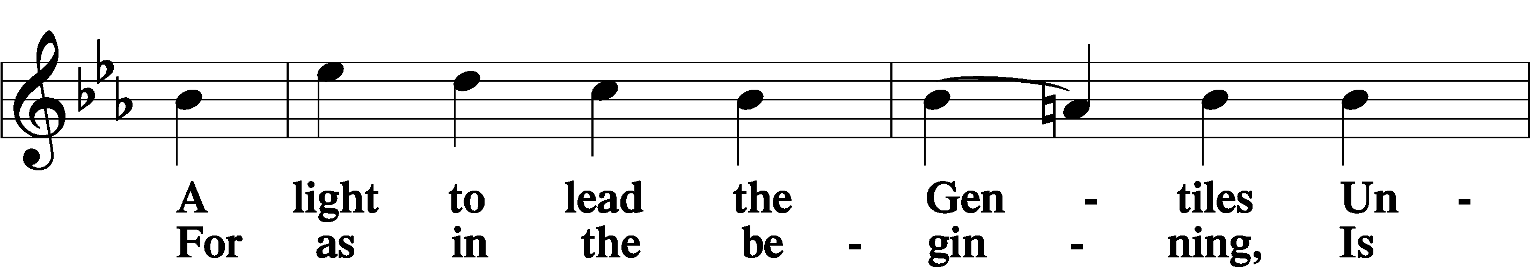
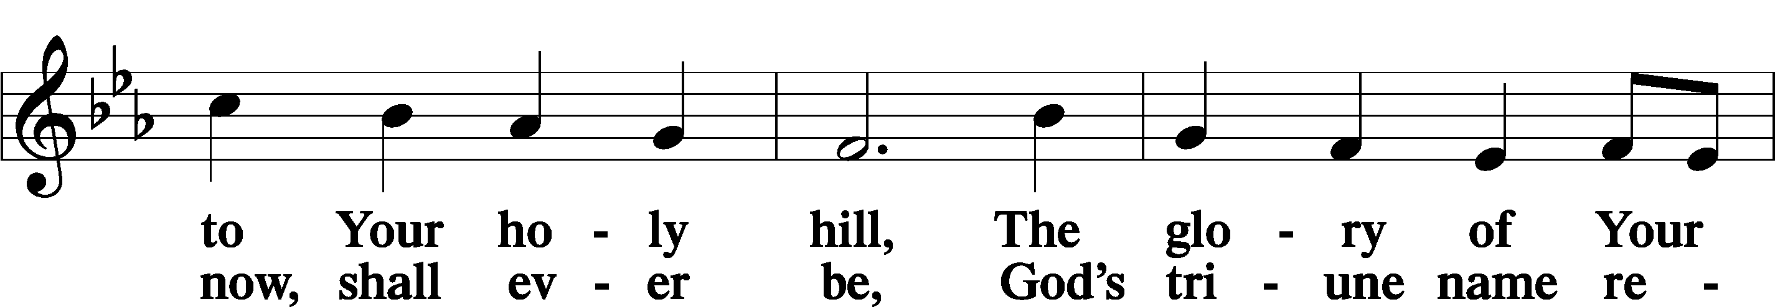
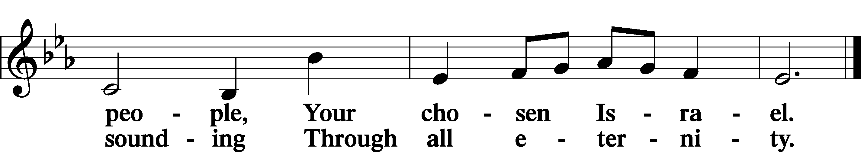

POST COMMUNION COLLECT
P Let us pray.
O God the Father, the fountain and source of all goodness, who in loving-kindness sent Your only-begotten Son into the flesh, we thank You that for His sake You have given us pardon and peace in this Sacrament, and we ask You not to forsake Your children but always to rule our hearts and minds by Your Holy Spirit that we may be enabled constantly to serve You; through Jesus Christ, Your Son, our Lord, who lives and reigns with You and the Holy Spirit, one God, now and forever.
C Amen.

BENEDICAMUS LSB 212
P Let us bless the Lord.
C Thanks be to God.
BENEDICTION
P The Lord bless you and keep you.
The Lord make His face shine on you and be gracious to you.
The Lord look upon you with favor and T give you peace.
C Amen.

Please be seated
CLOSING HYMN
Alleluia! Sing to Jesus LSB 821 st. 5
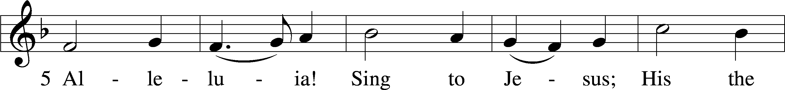
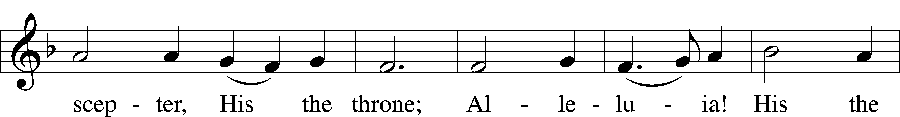
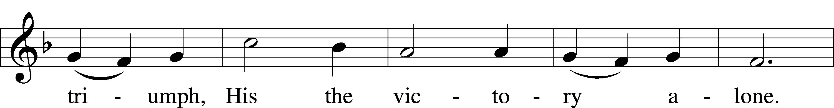
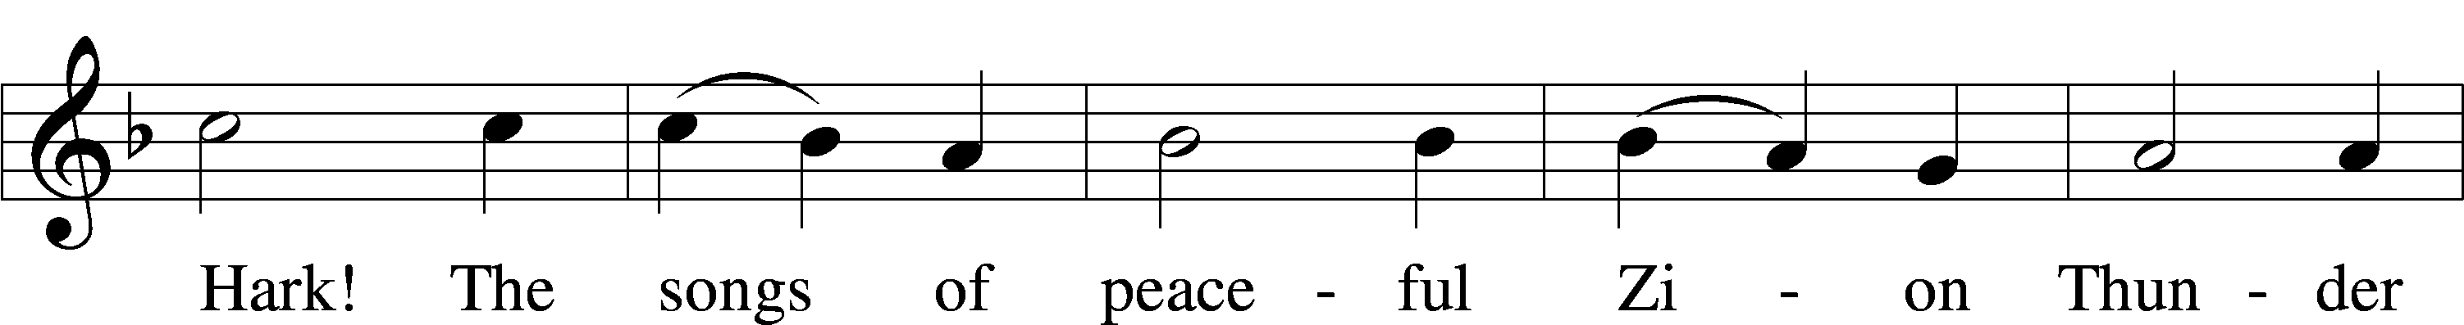
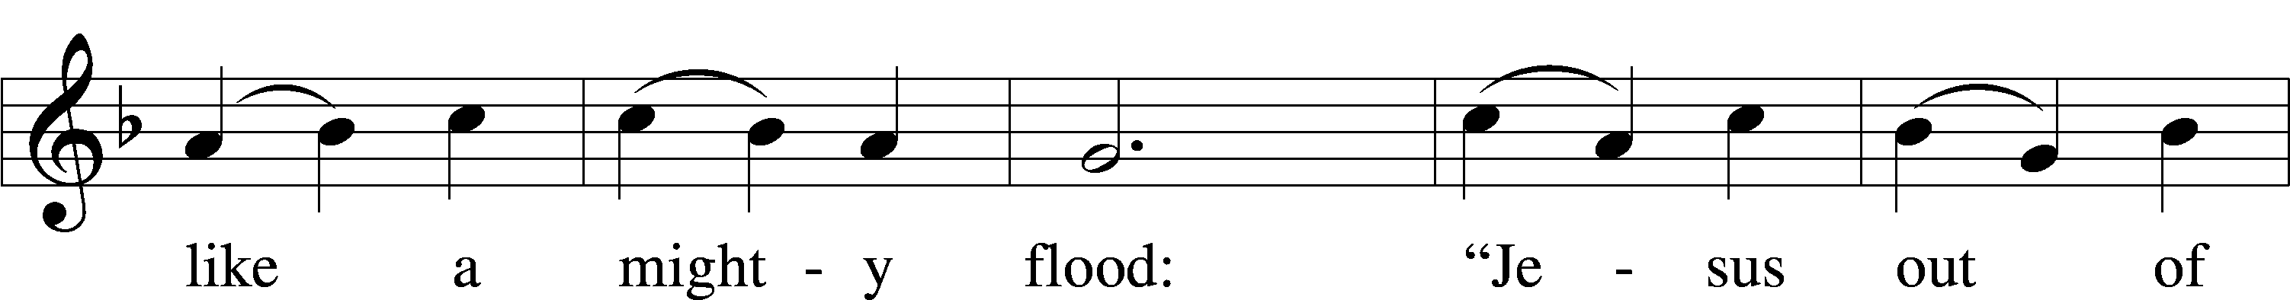
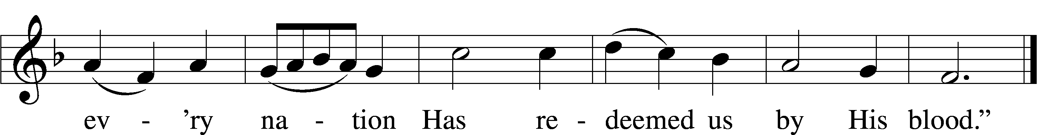

ANNOUNCEMENTS and SENDING WORDS
P We go to live for Jesus!
C We go to share His love!

Acknowledgments
Unless otherwise indicated, Scripture quotations are from the ESV® Bible (The Holy Bible, English Standard Version®), copyright © 2001 by Crossway, a publishing ministry of Good News Publishers. Used by permission. All rights reserved. Created by Lutheran Service Builde

SERVING in GODS HOUSE TODAY
Pastor: Rev. Ken Bernthal
Elder: Glen Smith
Ushers: Mike Goodrich, Roxie Mohr
Greeters: John & Judi Stutzman
Coffee Servers:
Counters: Kathy Erat, Donna Cottrell
Altar Care: Judi Stutzman
Piano/Organist: Tom & Jean Beach
Children’s Talk: Nancy Ely
Post Service Bible Study: Tom Beach
PRAYERS
Please contact the office with updates to the prayer list. People will remain on the prayer list for 4 weeks before being removed. If they need to remain on the list, please keep Elaine informed and of any updates. This will help us to have a more accurate list. Thanks for your cooperation.
Those who continue to grieve the passing of loved ones, The family of Ruth Luebs.
Those with upcoming surgery:
Those recovering from surgery: Tanner Beyers, Sasha (Rose Dittmans Grandson), Jennifer Martin, Ron Kwapis, and Marge Kunisch.
Those with health concerns: Tiffany Amsdill, Laurie Breen, Hope Buchinger,
Betsy Cook, Kay Gregg, Hilda Koch, Eleanor Raether, Beth Smith, Judi Stutzman, and Joann Whitney.
Those diagnosed with cancer: Leah Eicher, Rachel Frisch, Joe Gibson, Janice Knoellinger, Leslie Martin, Brian Morgan, Hope Osantowski, and John Stutzman.
Those under Hospice Home Care: Ken Williamson, Jim (Joann Whitney’s brother-in law).
BIRTHDAYS: ANNIVERSARIES;
6/26 Wally Beasinger 6/26 Jeremy & Michele Bartley
6/26 Brian Morgan
6/30 Morgan Armstrong
7/1 Bill Stiles
7/2 Gene Seibel
7/1 Noah Smith
MESSAGES

MEMBER & GUEST CARDS: If you have not filled out a member/guest card, please take the time to fill one out and place it in the plate behind the back pews in our sanctuary.
GREETING CARDS If you are in need of some greeting cards, we carry an array of them in the cabinet in the library. The cost of the cards is posted on the cabinet. The money collected from the cards goes to LWML to help support Missions.
LWML SUMMER POP-UP CRAFT SALES: LWML plans to have occasional mini craft sales this summer. With short notice we will set up a few canopies in the front yard and offer our crafts for sale, with the profits designated for missions, both locally and throughout the world. Dates have yet to be determined. So, crafters, please get thinking about what handmade items you can prepare in advance for us to sell. We welcome and appreciate your donations.

FLOWERS: There are still spots open for Altar flowers, if you have birthdays, anniversaries, new baby or in memory of someone, or just for something special like dressing up the Altar. The sign-up sheet is in the fellowship hall as you go in the door. Flowers are $30.00 for the two flowers. Order them, they will be put on the altar, after the service then take them home to enjoy.
CANCER & FRIENDS SUPPORT GROUP: Our meetings are the 4th Tuesday of each month at 5:30pm. The meetings are for everyone. It is for cancer patients, spouse, care-givers, and loved ones. We all have special needs when it comes to cancer. Cancer is hard for everyone involved not just the patient. You need to understand what the patient is going through and the cancer patient has to understand what everyone else is going through. It not easy for anyone. That is why we bring in different guest speakers. We are here for that helping hand you may need. Our guest speaker of this month is Dona Wishart from OCCOA. Dona comes with a wealth of information about OCCOA, how they can help us and what they have to offer us. For more information you can contact Elaine by email elaineraschke@gmail.com or text to 989-350-4391.
MAIL BOXES: We will be changing the mail boxes with in the next few weeks.
PORTALS OF PRAYER for July – September are in and on the shelf in the narthex.
CHURCH PICNIC: July 24th here at Trinity following the service. There are sign up sheet on the board in the narthex, if you are going to attend the picnic please sign up on that sheet, we also have sign up sheets for volunteer’s that are needed to help with the picnic please check the board for the volunteer sheets.
NOISY OFFERING: (We invite you to put your pocket change in the buckets located at the back of the church where the membership cards are located to support our local Food Pantry.)

THIS WEEK AT TRINITY
June 26 Sunday
9:00 am Worship Service
Noisy Offering
10:00 am Fellowship & Coffee Hour
10:30 am Bible Study
June 27 Monday
June 28 Tuesday
5:30 pm Cancer & Friends Support Group – Fellowship Hall
June 29 Wednesday
June 30 Thursday
July 1 Friday
July 2 Saturday
10:00 am Stephen Ministry Peer Supervision Meeting
July 3 Sunday
9:00 am Worship Service
10:00 am Fellowship & Coffee Hour

SERVING IN GOD’S HOUSE NEXT SUNDAY 7/3/2022
Pastor: Rev. Paul Schneider
Elder: Ken Mertz
Ushers:
Greeters: Larry & Joann Whitney
Counters: Brian Techel, Karl Scheiterlein
Coffee Servers:
Alter Care: Pam Beasinger
Virtual Organist: Bob Erat
Children’s Talk: Nancy Ely
Post Service Bible Study: Tom Beach

